**Aim**: Design and simulate IoT scenario. Scenario is Smart Home

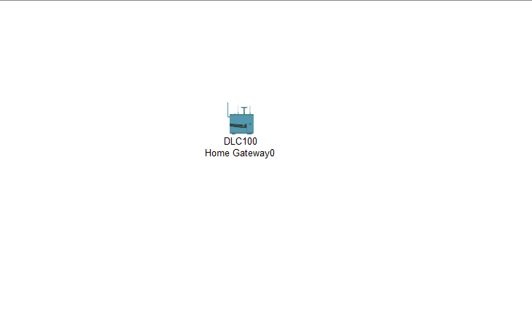**Step – 1:-** Take One Home Gateway

**Step – 2 :-**  Take one Light and Celling Fan.

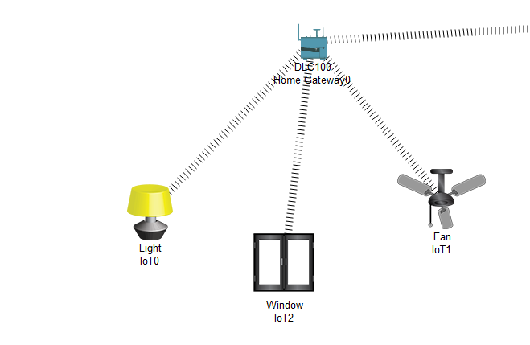

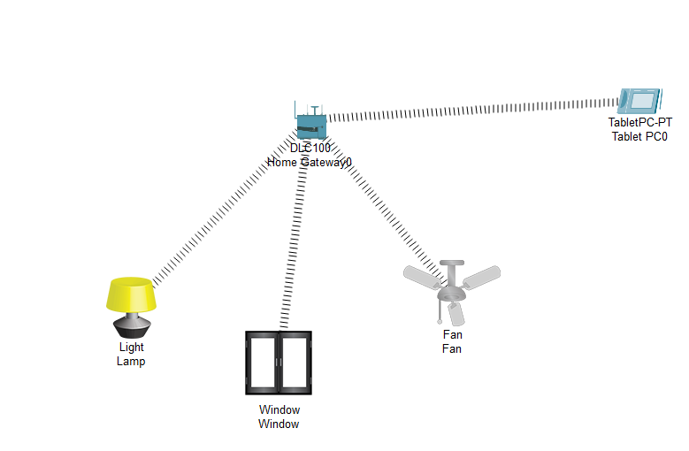**Step – 3 :-**  Take One Tablet.

**Step – 4 :-**  Now Configure the Tablets Wireless SSID to HomeGateway.

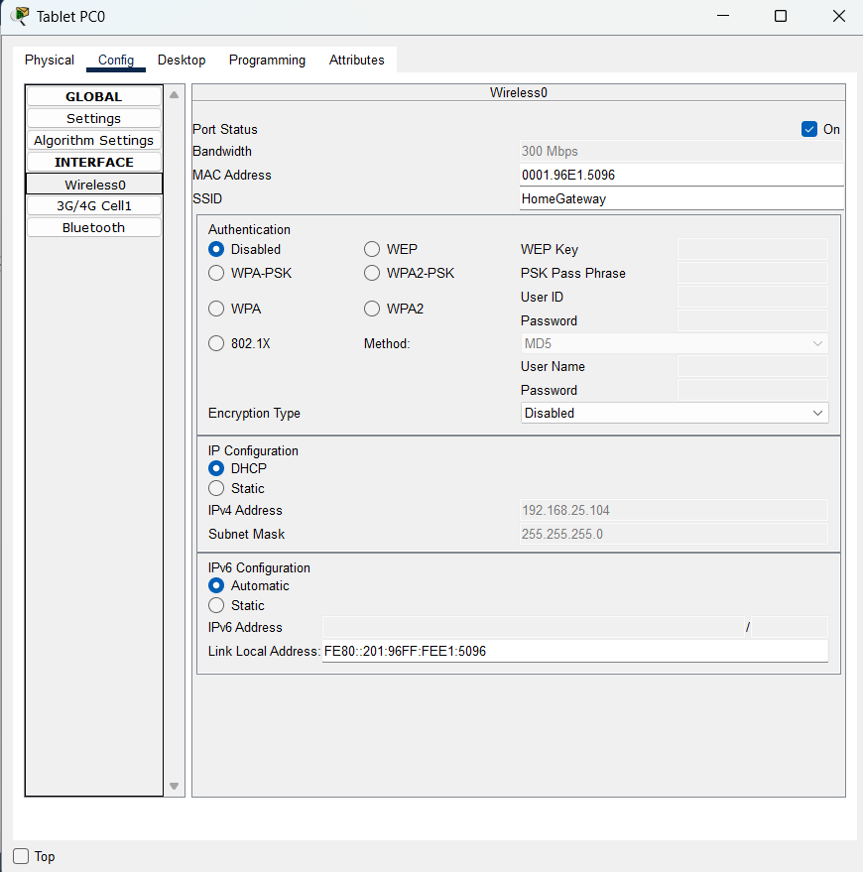

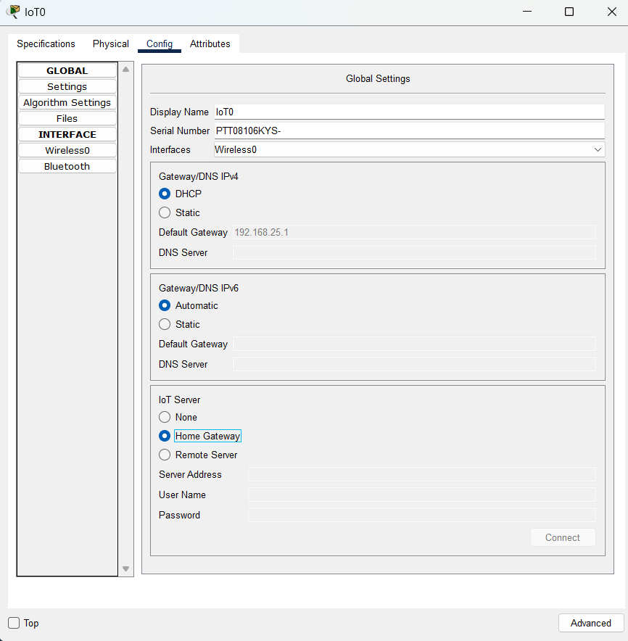**Step – 5 :-**  Now we will Register all the devices on HomeGateway.for that go to device>config > Iot Services > Choose HomeGateway

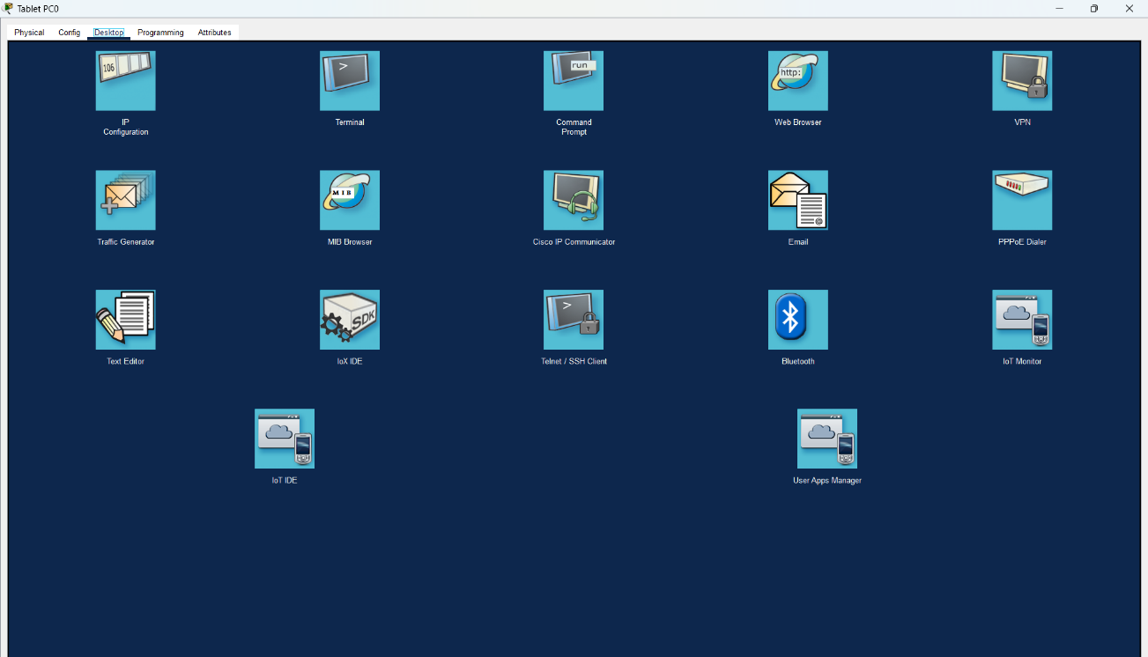**Step – 7:-**  Now we will Define the Condition. When the Door is Open, the Fan and Lamp should be off. when the door is closed, the Lamp and Fan are On. Go to Tablet > Desktop > Iot Monitor

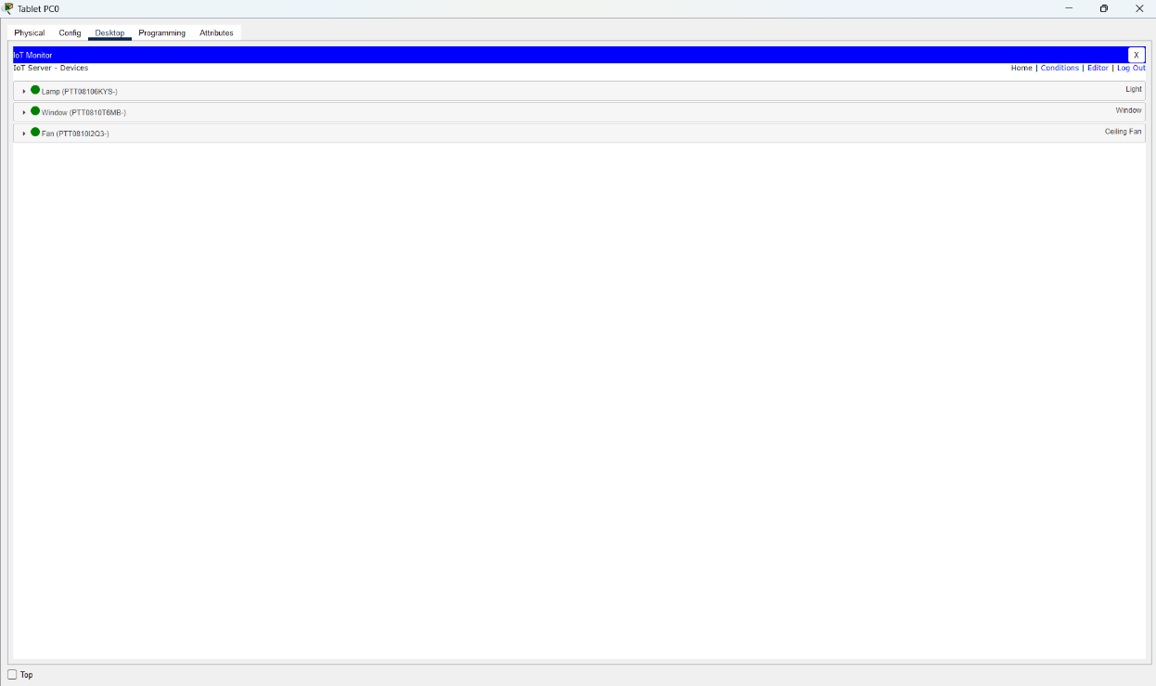Log in into it by pressing login button it will display all the registered device in this case it will be lamp , fan and door.

To add condition go to condition.

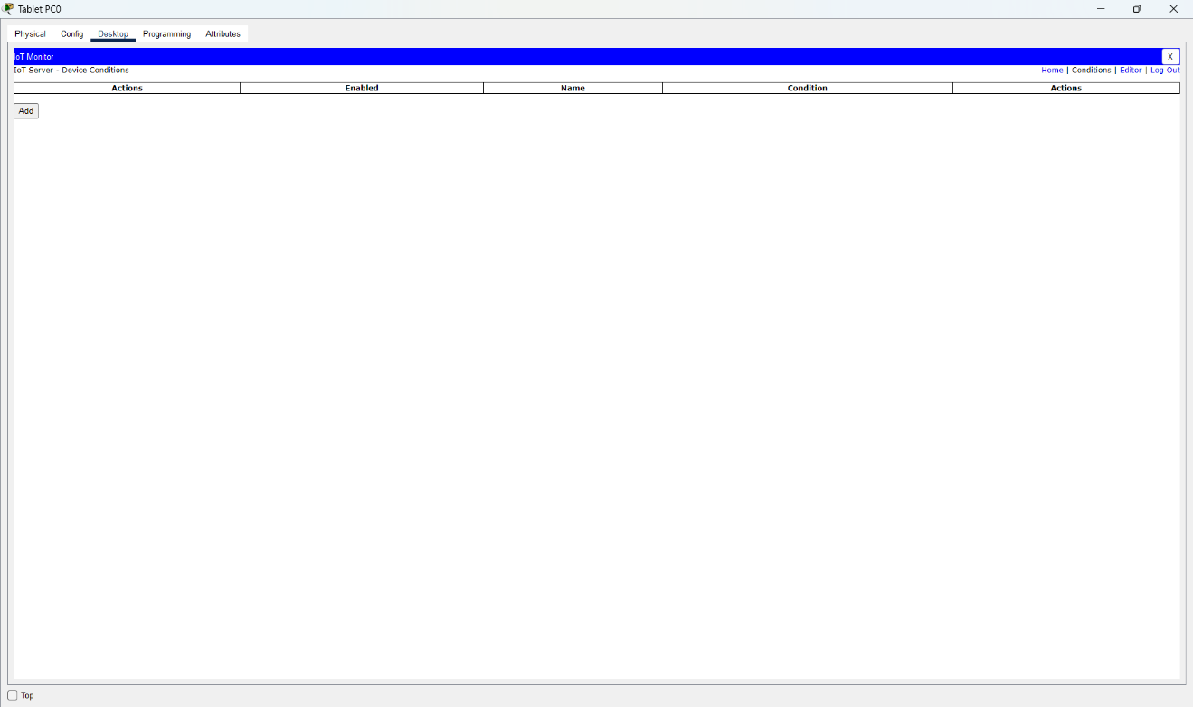

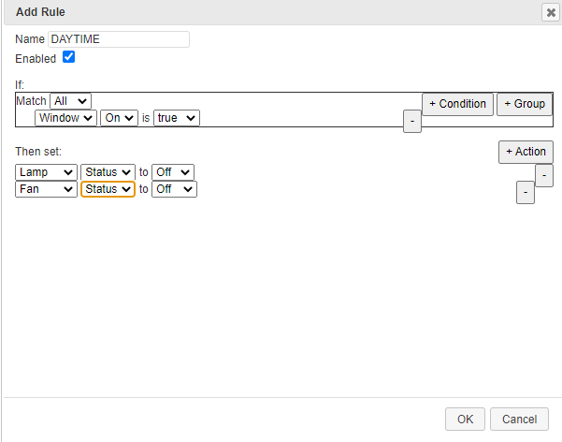this is our first condition. when window is open lamp and fan should be off.

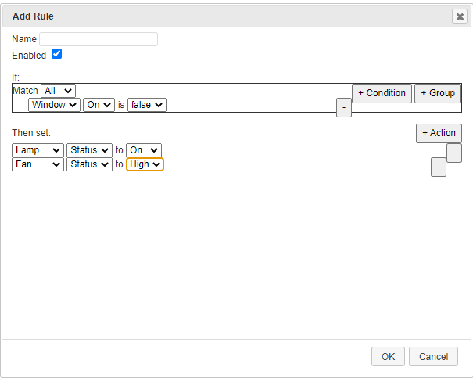this is our second condition when window is close then fan and lamp should be on.

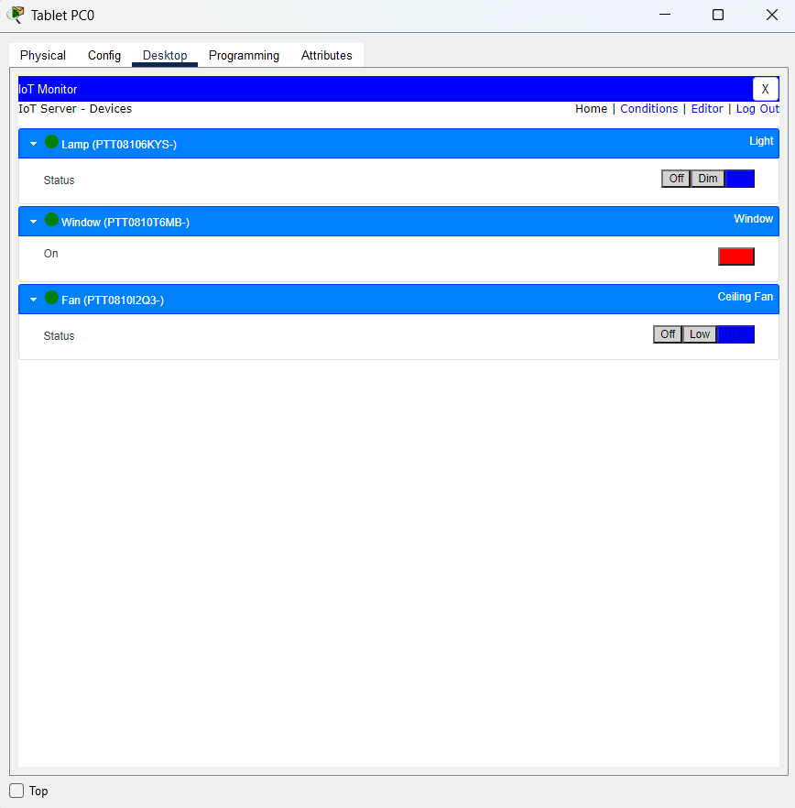Now we will Simulate our Scenario.

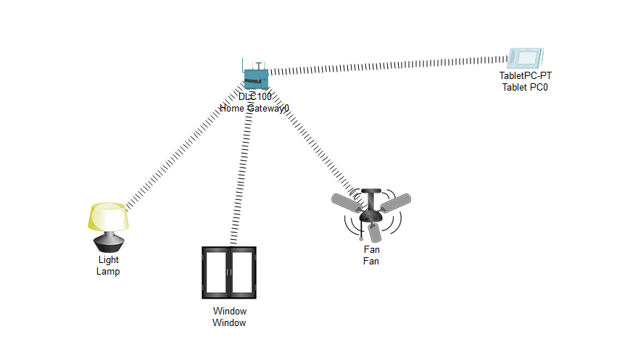

In the Night time when window is off fan and light is on.

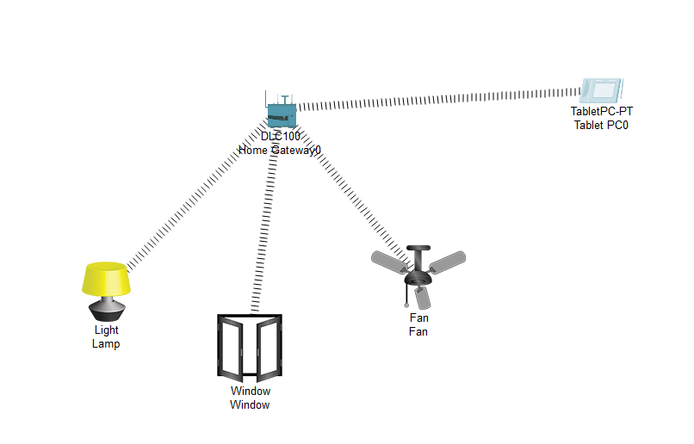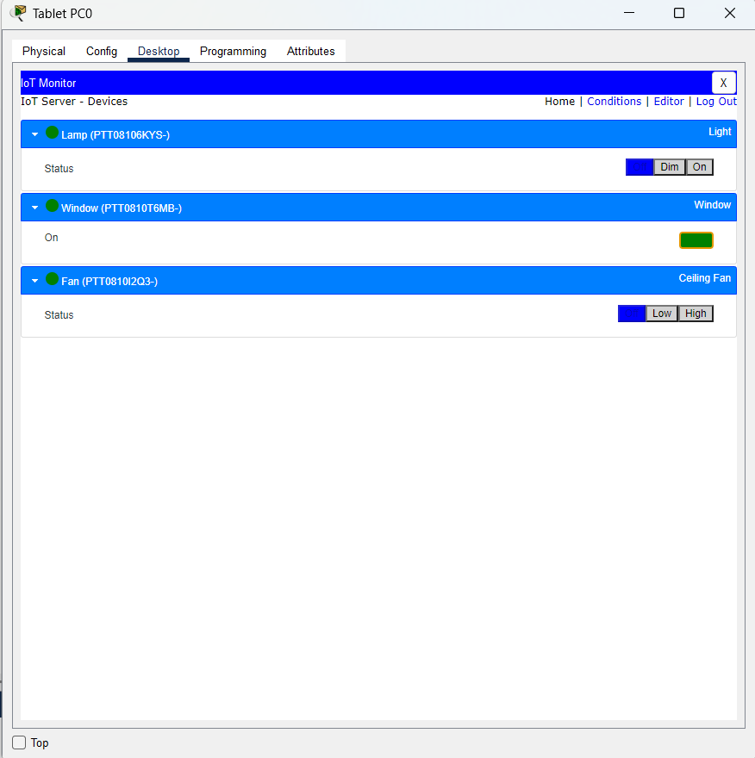

In the Day Time when window is open the light and fan should be off.

**Conclusion:-**

By Performing this Scenario I learnt How Iot Devices are controlled within the same Network. I leant how to register a device on tablet. How set SSID , how to add conditions. and Learnt to simulate it.